**Record Category, Groups and Rules**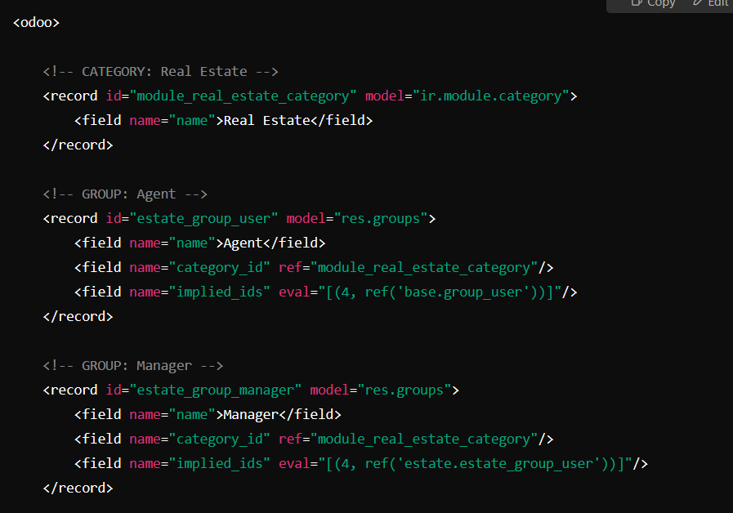

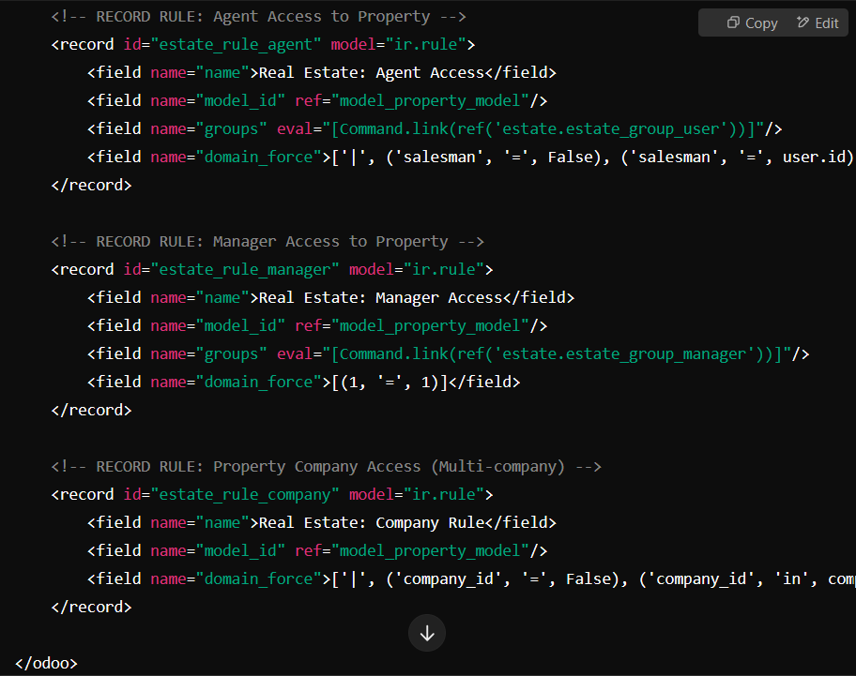

**Access Right in XML**

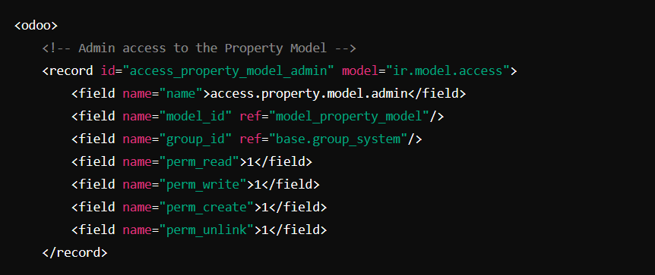

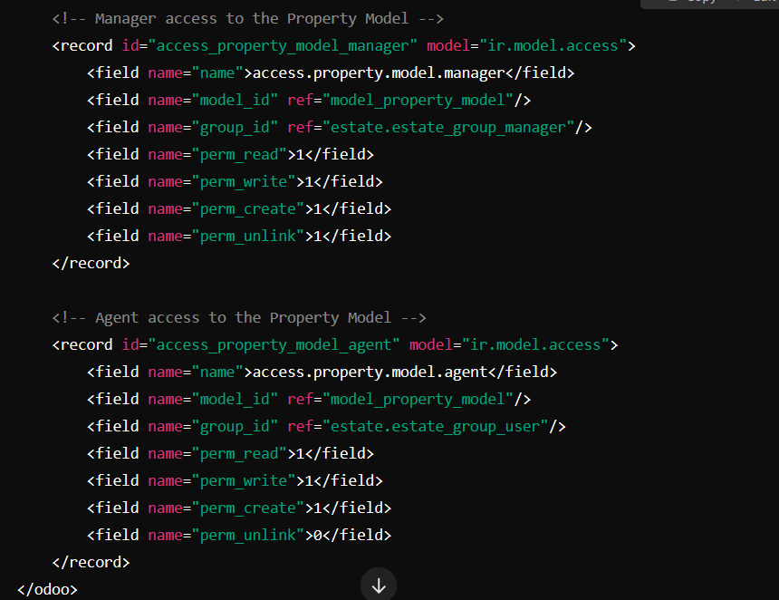

* **name**: A unique identifier for the access rule.
* **model_id**: The model for which the access rights are defined (e.g., model_product_product).
* **group_id**: The user group that the rule applies to (e.g., base.group_user).
* **perm_read, perm_write, perm_create, perm_unlink**: Flags (1 for allowed, 0 for denied) for CRUD operations.

**Access Right in CSV**

**Access Rights for estate.property Model**

| **ID** | **Name** | **Model ID** | **Group ID** | **Read** | **Write** | **Create** | **Unlink** |
| --- | --- | --- | --- | --- | --- | --- | --- |
| access_property_model_manager | access.property.model.manager | model_property_model | estate.estate_group_manager | 1 | 1 | 1 | 1 |
| access_property_model_agent | access.property.model.agent | model_property_model | estate.estate_group_user | 1 | 1 | 1 | 0 |

**Access Rights for estate.property.type Model**

| **ID** | **Name** | **Model ID** | **Group ID** | **Read** | **Write** | **Create** | **Unlink** |
| --- | --- | --- | --- | --- | --- | --- | --- |
| access_property_type_model_manager | access.property_type.model.manager | model_property_type_model | estate.estate_group_manager | 1 | 1 | 1 | 1 |
| access_property_type_model_agent | access.property_type.model.agent | model_property_type_model | estate.estate_group_user | 1 | 0 | 0 | 0 |

**Access Rights for estate.property.tag Model**

| **ID** | **Name** | **Model ID** | **Group ID** | **Read** | **Write** | **Create** | **Unlink** |
| --- | --- | --- | --- | --- | --- | --- | --- |
| access_property_tag_model_manager | access.property_tag.model.manager | model_property_tag_model | estate.estate_group_manager | 1 | 1 | 1 | 1 |
| access_property_tag_model_agent | access.property_tag.model.agent | model_property_tag_model | estate.estate_group_user | 1 | 0 | 0 | 0 |

**Access Rights for estate.property.offer Model**

| **ID** | **Name** | **Model ID** | **Group ID** | **Read** | **Write** | **Create** | **Unlink** |
| --- | --- | --- | --- | --- | --- | --- | --- |
| access_property_offer_model | access.property.offer.model | model_property_offer_model | estate.estate_group_user | 1 | 1 | 1 | 1 |

**Access Rights vs Record Rules**

* **Access Rights**: Control the user's ability to perform CRUD operations at the model level.
* **Record Rules**:

Apply filters to restrict access to specific records within a model based on conditions.

Control which specific records a user can see or interact with within a model.